ST. XAVIER’S COLLEGE

**(Affiliated to Tribhuvan University)**

**Maitighar, Kathmandu**



Computer Graphics

Lab Assignment #1

**SUBMITTED BY:**

Utsav Luitel

013BSCCSIT046

Sem IV

**SUBMITTED TO**

|  |  |
| --- | --- |
| Er. Anil K. Sah  (Lecturer) |  |
| Department of Computer Science | |

**Date of submission: August 04, 2015**

**STATEMENT: DRAW THE FOLLOWING CHECKBOX IN C++ BUILDER**

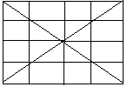

**SOURCE CODE:**

//---------------------------------------------------------------------------

#include <vcl.h>

#pragma hdrstop

#include "Unit1.h"

//---------------------------------------------------------------------------

#pragma package(smart_init)

#pragma resource "*.dfm"

TForm1 *Form1;

//---------------------------------------------------------------------------

__fastcall TForm1::TForm1(TComponent* Owner) : TForm(Owner)

{

}

//---------------------------------------------------------------------------

void __fastcall TForm1::Button1Click(TObject *Sender)

{

Form1->Canvas->Pen->Width=3;

Form1->Canvas->MoveTo(10,10);

Form1->Canvas->LineTo(200,10);

Form1->Canvas->MoveTo(10,10);

Form1->Canvas->LineTo(10,200);

Form1->Canvas->Pen->Width=2;

Form1->Canvas->LineTo(200,200);

Form1->Canvas->LineTo(10,10);

Form1->Canvas->MoveTo(200,200);

Form1->Canvas->LineTo(200,10);

Form1->Canvas->LineTo(10,200);

Form1->Canvas->MoveTo(105,10);

Form1->Canvas->LineTo(105,200);

Form1->Canvas->MoveTo(53,10);

Form1->Canvas->LineTo(53,200);

Form1->Canvas->MoveTo(153,10);

Form1->Canvas->LineTo(153,200);

Form1->Canvas->MoveTo(10,105);

Form1->Canvas->LineTo(200,105);

Form1->Canvas->MoveTo(10,55);

Form1->Canvas->LineTo(200,55);

Form1->Canvas->MoveTo(10,155);

Form1->Canvas->LineTo(200,155);

}

//---------------------------------------------------------------------------

**OUTPUT**

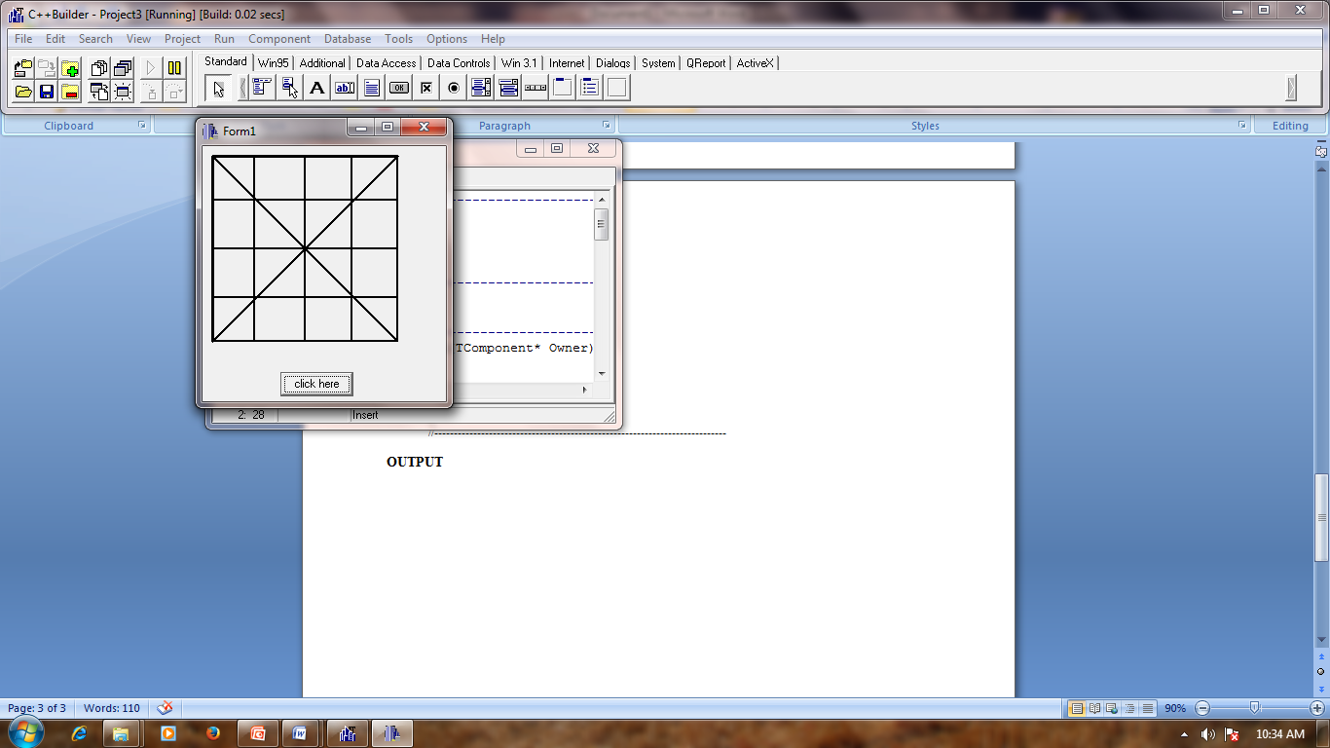

**CONCLUSION:**

Therefore we conclude that by the use of c++ builder we can build the cheaker boxof various pattern.

**REFERENCE:**

**[1.]** http://www.cbexamples.com/